Name: Arpit Mahalle
Day 17 Nodejs Assignment output screenshot

Challenge 4
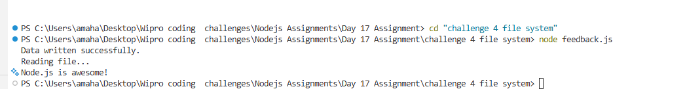

This screenshot shows the fs module successfully writing feedback to a file and reading it back in the terminal.

Challenge 5
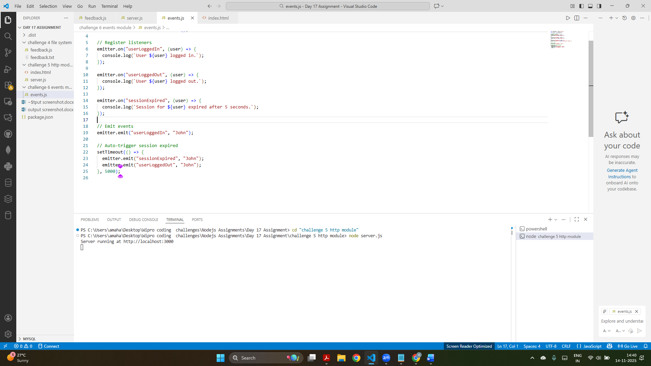
This screenshot shows the event emitter code in VS Code alongside the terminal running the HTTP server.

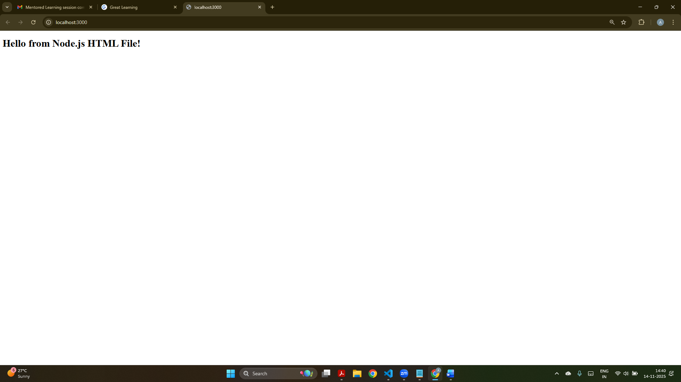
This screenshot displays the homepage served by the HTTP server, loading content directly from the index.html file.

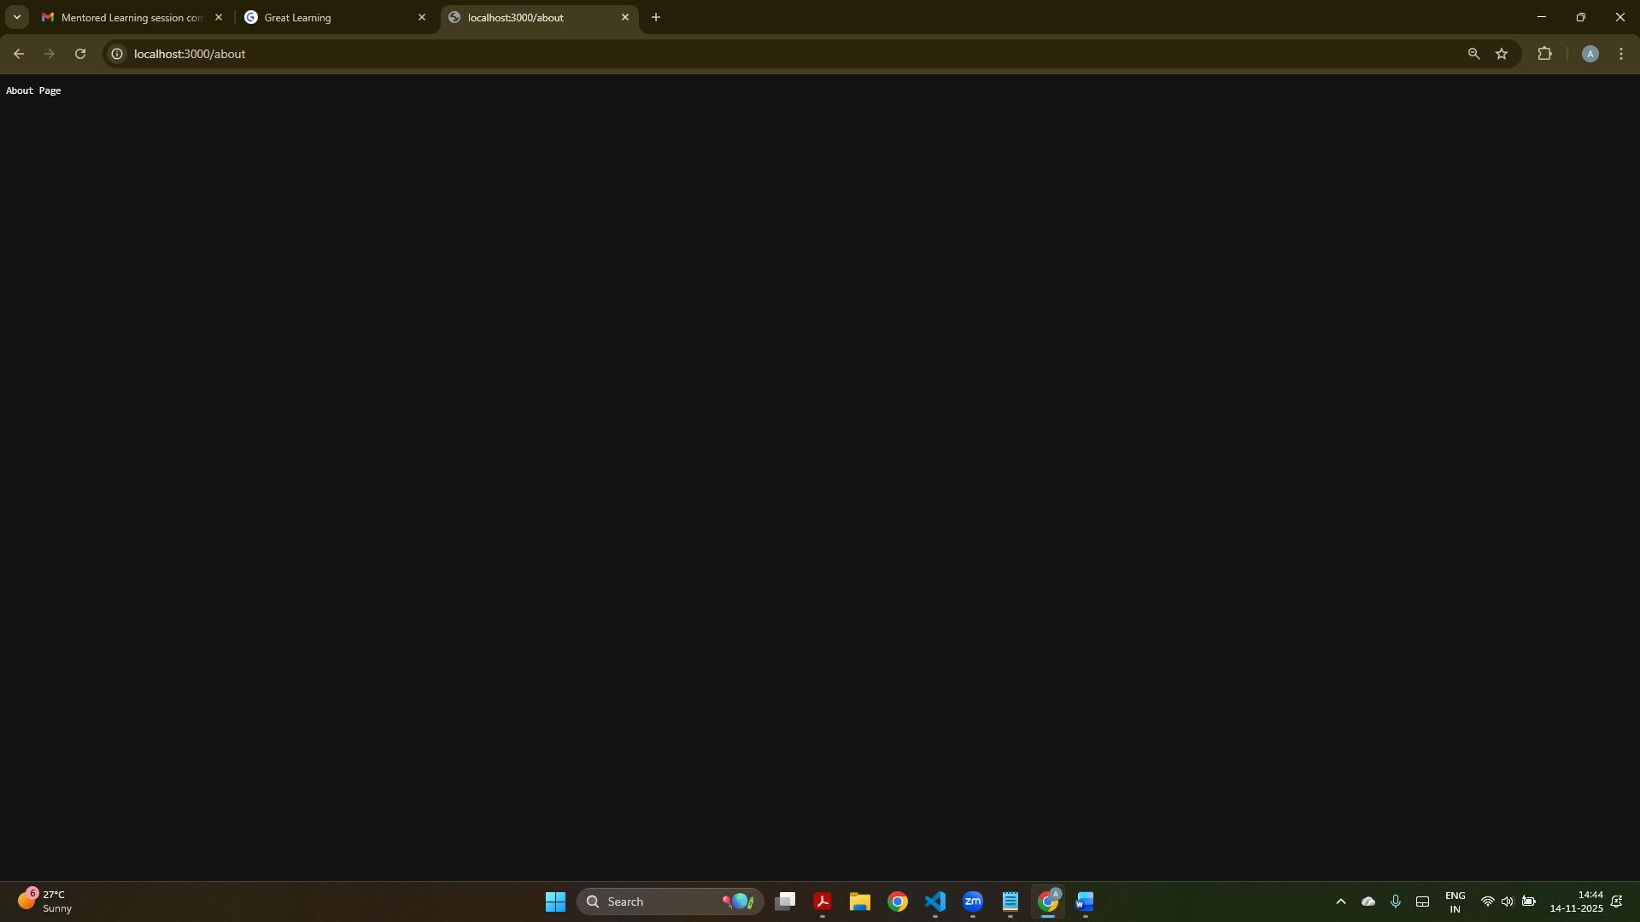
This screenshot shows the "/about" route returning the plain text “About Page” from the Node.js server.

Challenge 6

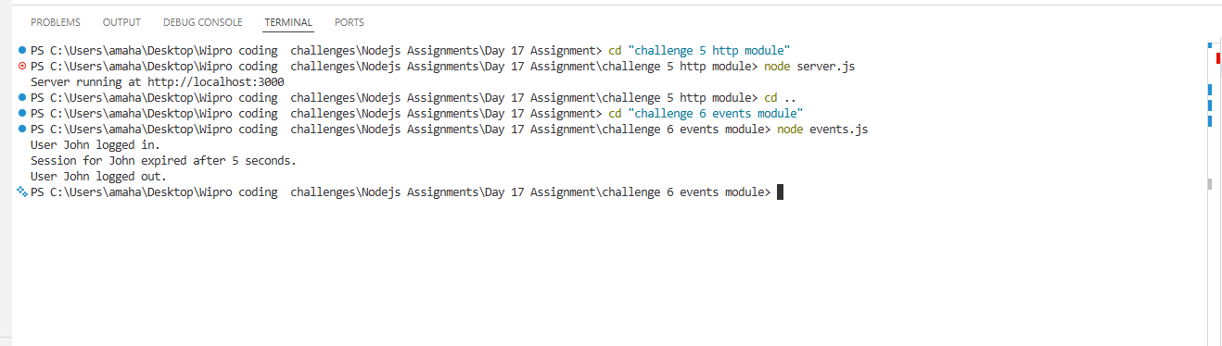

This screenshot shows the events module output where user login, session expiration, and logout messages are triggered.

